Jake Sloan

MI349

12/11/22

Website Pre write up

For this final project, I will be making a portfolio displaying some of the work that I have worked on over the past few years. It will display a few screenshots from different things I have created, as well as an about page where somebody can get into contact with me. I want to keep the website somewhat simple. Simplicity is a good value to have in a website. You do not want it to be too overbearing to the readers. These are a few mock ups along with a pitch board to showcase the idea.

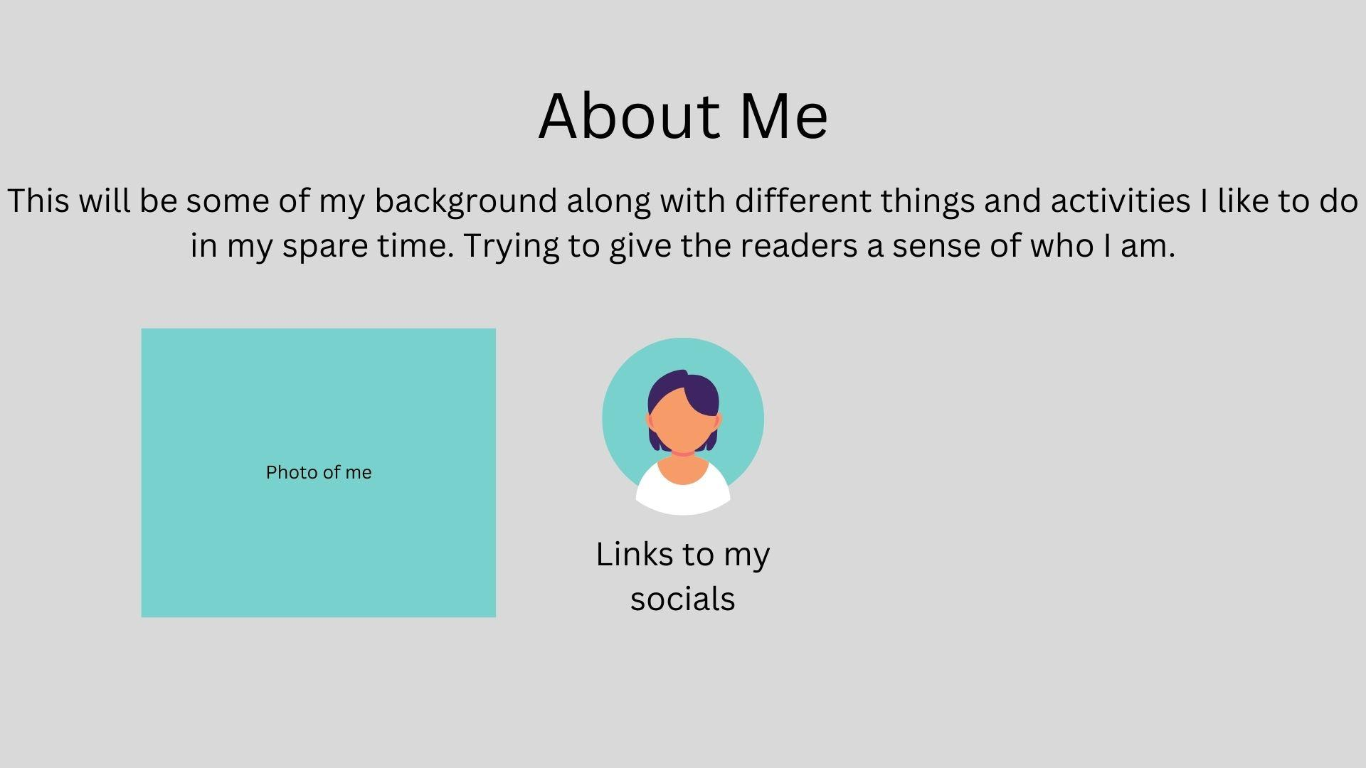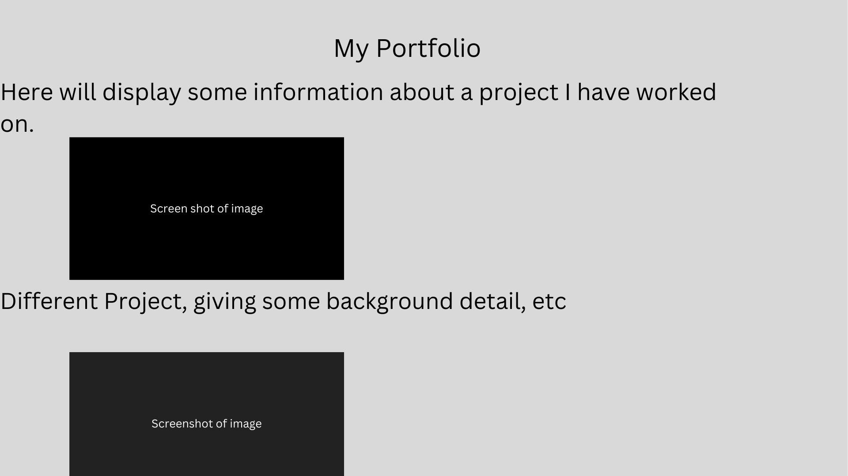

I think this is a good guess of what I want this website to end up looking like. I want to keep it simple and easy for the readers to read and check out.

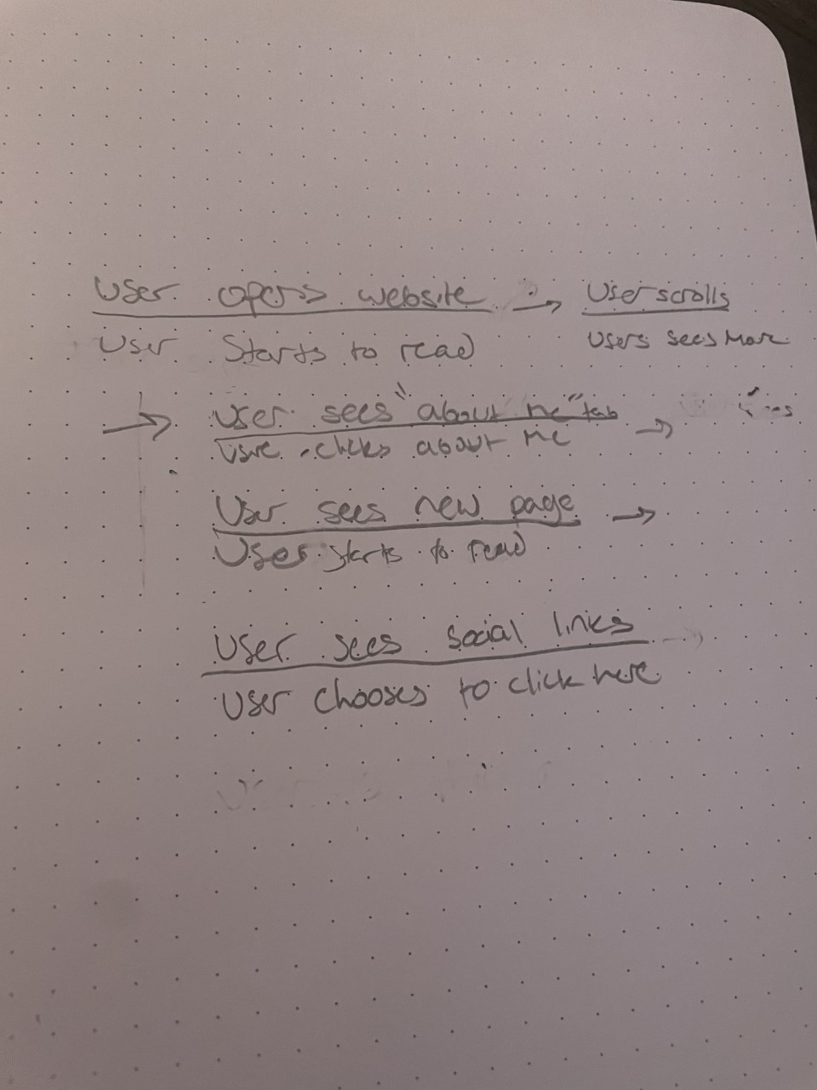 This is a workflow mock-up of the write up. I hope this helps to achieve the flow that I would like to have for this website.